Student Health Form
PART 1 – HEALTH INFORMATION FORM
This part is to be completed by a parent:
Student’s Name: ________________________________________ Current Grade: _________________________________________________
Student’s Date of Birth: ________ /_________ /____________ Student’s Address: ____________________________________________
Name of Mother: ________________________Cell Phone: ______________________ Work Phone: ________________________________
Name of father: _________________________ Cell Phone: _____________________ Work Phone: _________________________________
In case of emergency- If parent or guardian cannot be contacted- contact the following:
- Name: _______________________________________ Phone Number: _______________________________________________________
- Name: _______________________________________ Phone Number: _______________________________________________________
Does the student have a history of any of the following?
 | Y | N | Comments |  | Y | N | Comments
Allergies (Food, Insects, drugs, seasonal) |  |  |  | Hearing problems or Deafness
asthma or breathing problems |  |  |  | Vision problems
Diabetes |  |  |  | Muscle problems
Cancer |  |  |  | Speech problem
Seizure |  |  |  | Heart disease
Bleeding problems |  |  |  | Chicken pox
Bladder problems |  |  |  | Measles
Bowel problems |  |  |  | Mumps
Skin problems |  |  |  | Head injury, Concussions
Developmental problems |  |  |  | Dental problems
Attention- deficit/ hyperactivity disorder |  |  |  | Surgery
Other serious illnesses
Is your child on regular medication? If so, please state:

If your child has an allergy, please indicate possible allergic reactions and appropriate response:

Specify special needs:

Other comments:

Please provide the following information for your child’s record:
 | Name | phone
Pediatrician
Dentist
Assistant (if applicable)

Does any of the family members have a history of medical problems?
No Yes (if yes, please specify)

PART 2- COMPREHENSIVE PHYSICAL EXAMINATION REPORT
This part is to be filled out and signed by the doctor.
Clinical Examination | Findings/Comments
Height
Weight
BMI for age
HEENT (Head, Eyes, Ears, Nose, Throat)
Skin
Heart
Lungs
Abdomen
Extremities
Back and posture
Neurologic
Genitalia (undescended testicles, varicocele, hydrocele)
Other

Laboratory test:
Blood type: ___________________________________________

Doctor’s signature and stamp ___________________________________ Date ________________________
PART 3- SCREENING TESTS
Part three, four, and five are to be filled out at the school.
Body Measurements
 | Grade 1 | Grade 5 | Grade 8
Date of exam | / / | / / | / /
Weight
Hight
BMI
Comments/Recommendations

Ear Assessment
 | Grade 1 |  | Grade 5 |  | Grade 8
Date of exam | / / |  | / / |  | / /
Ear | R | L | R | L | R | L
Otoscopy (pass, fail)
Comments/Recommendations

Eye Assessment
 | Grade 1 |  | Grade 5 |  | Grade 8
Date of exam | / / |  | / / |  | / /
Eye | R | L | R | L | R | L
Acuity (with glasses/without glasses)
Strabismus (Yes, No)
Conjunctivitis (Yes, No)
Referral to an ophthalmologist (Yes, No)

Back and Posture Assessment
 | Grade 5 | Grade 8
Date of exam | / / | / /
Postural screening  (Scoliosis, kyphosis, lordosis and others) | Pass  Fail | Pass  Fail
Comments/Recommendations

Oral and Dental Health Assessment

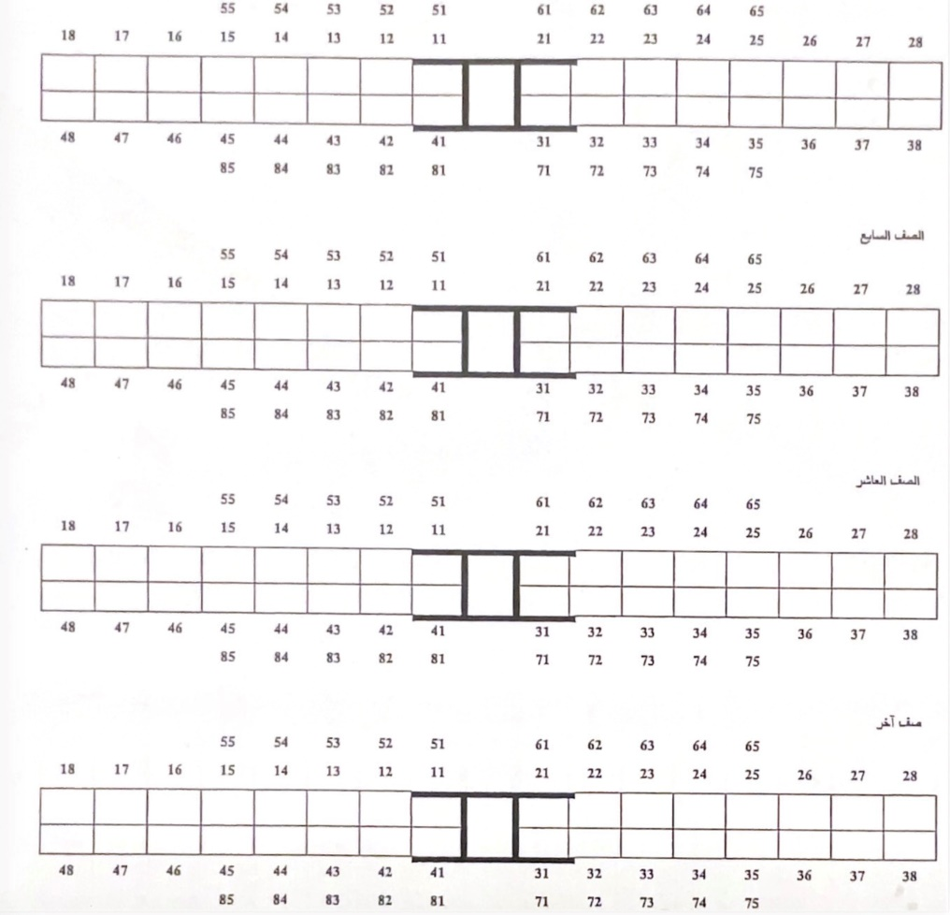
1st Grade
Healthy
A
Primary
Dental Health Status
Permanent
0
Decay
B
1
Other
Periodontal health status:
Tooth fracture
Supernumerary teeth
Unerupted teeth
Crown or bridge
Fissure sealant
Lost or missing teeth for other reasons
Missing teeth due to decay
Filling & no decay
Decay & filling
T
-
-
G
-
F
E
D
C
10
9
8
7
6
5
4
3
2

7th Grade

10th Grade

36/37
31
46/47
26/27
16/17
11
26/27
11
16/17
1st Grade
7th Grade
Inflamed & bleeding
Healthy
0
1
2
Calculus
36/37
31
46/47
36/37
31
46/47
16/17
11
26/27
16/17
11
26/27
10th Grade
Other
Malocclusion:
Fluoride:
46/47
31
36/37
Mild
Moderate
Normal
Sever
2
0
1
3
Normal
0
1st Grade
7th Grade
1st Grade
7th Grade
10th Grade
Mild fluorosis
Moderate
1
2
10th Grade
Other
Other
Heavy
3
Date: / / Doctor’s name: ------------------------------ Signature: -----------------------
Date: / / Doctor’s name: ------------------------------ Signature: -----------------------
Date: / / Doctor’s name: ------------------------------ Signature: -----------------------

Part 4- IMMUNIZATION RECORDS (taken at school).

Grade/age | Date  signature | O.P.V.  لقاح شلل الأطفال | D.T. Child  لقاح الدفتيريا والكزاز (أطفال) | d.T. Adult  لقاح الدفتيريا والكزاز (كبار) | Other vaccines | Notes
First grade/  6 years | Date
First grade/  6 years | signature
Ninth grade/  15 years | Date
Ninth grade/  15 years | Signature
 | Date
 | Signature
Part 5- ILLNREESE AND INJURIES THAT A STUDENT MAY EXPERIENCE DURING THEIR YEARS OF STUDY, INCLUDING INFECTIOUS DISEASES.

Date | Grade | Diagnosis | Doctor’s recommendations | Notes | Doctor’s name

